In this assignment, we will continue to improve our understanding of SMoL through the Stacker. The same rules apply to this assignment as in Stacks 1 Handout.

This assignment has four problems. All four show a configuration (or pair of configurations) and ask you to construct a program that could have produced what you see. Once again, we want you to get as close to an exact match as possible (modulo the random addresses).

For each program, transcribe your reasoning: what caused you to produce this particular program?

A Note About Writing:

Please don’t turn in stream-of-consciousness prose. You can write that as a rough draft to yourself if you like, but please go over it and clean it up before turning it in. Ideally, arrange it as a bulleted list or other organized form of deductions instead of an unstructured paragraph or wall-of-text.

Even if your paragraph is well-structured, a format like a bulleted list will make following it easier. Imagine taking an item-by-item recipe and merging it all into a single paragraph — or putting all the statements in your program on a single line…

If your text is too hard to read, we won’t grade it.

Finally: answer this question. The Atlantic magazine has a game called Bracket City. Why are we mentioning it in relation to this pair of assignments? Answer as precisely as possible.

1.

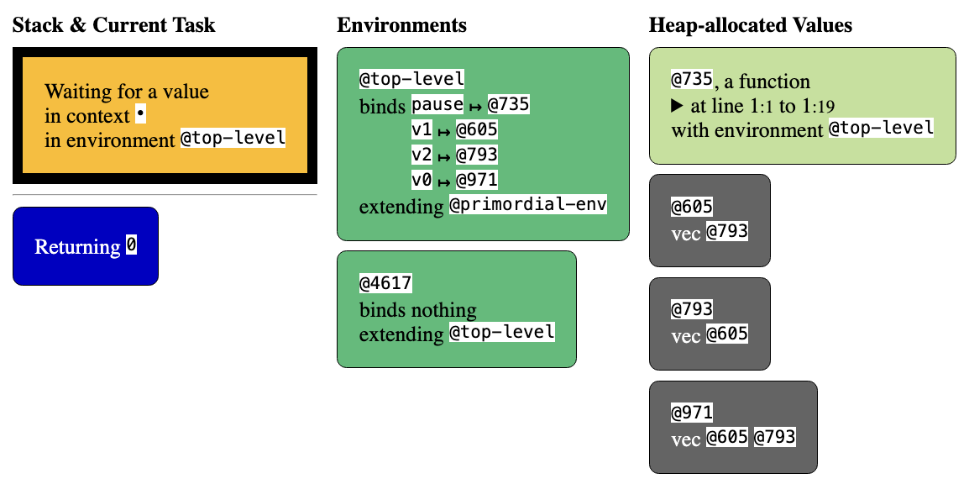

The “Returning 0”, the environment @4617, and the function value are from pause. You should include pause in the program that you construct.

2.
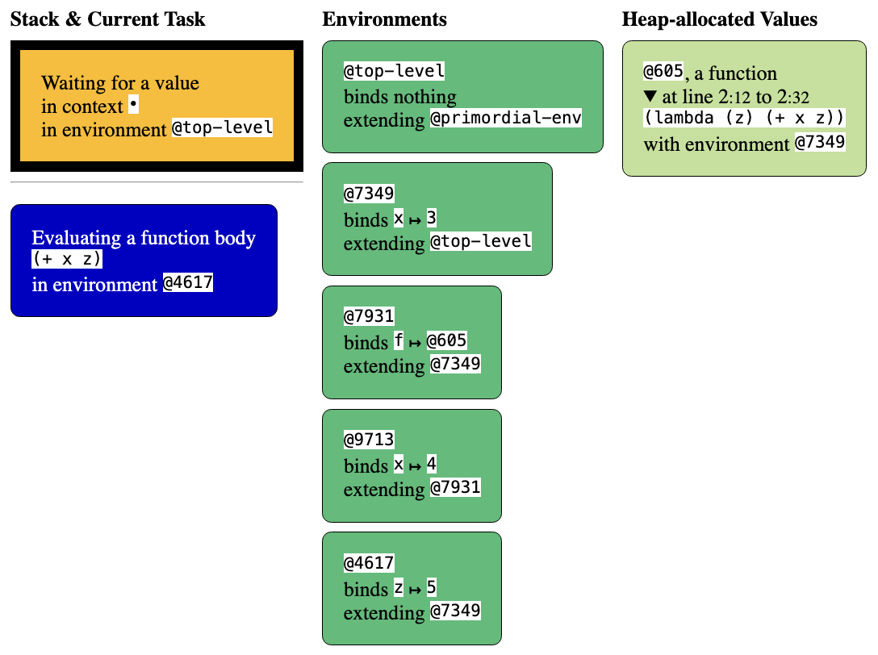
3.

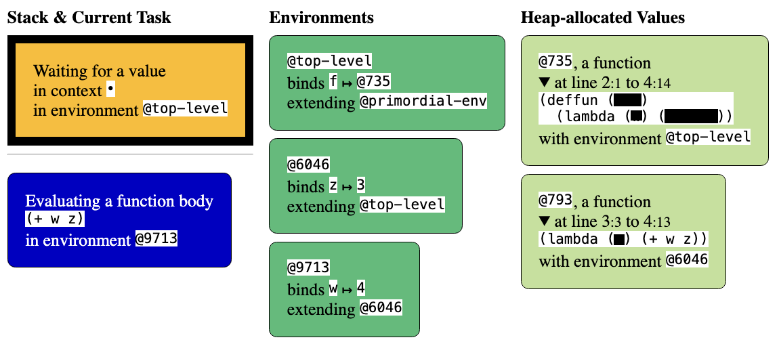

4.

Here is a pair of configurations, C1 and C2, with a few steps skipped in-between (concretely, Next was clicked 5 times after the first to obtain the second, but your solution does not need to match that exactly as long as it makes sense):

C1:
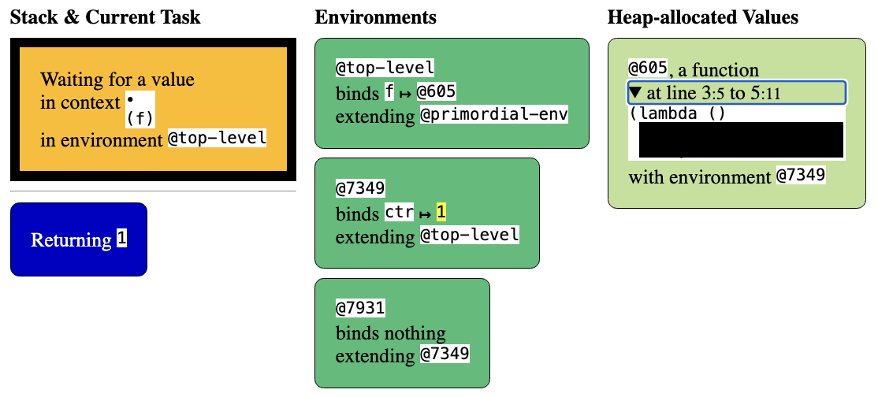

C2:
